1. Create a query to return the following columns from the **Album**, **Artist** and **Subgenre** tables for albums in the **@**subgenre. By passing subgenre name to stored proc we should get the result for that specific subgenre.

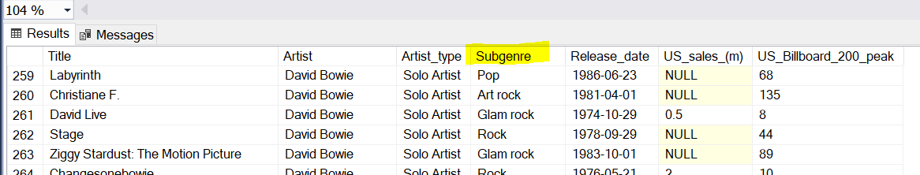

Tables:

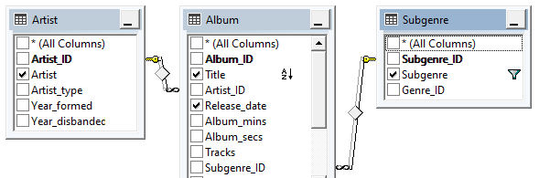

1. Create a stored proc query to return the following columns from the **Artist**, **Tour** and **Show** tables:

